How to Upload/Update bulk data in Oracle Fusion using REST API and Postman Collection.
We use FBDI for loading bulk data into Oracle fusion. But wherever FBDI is not available, we will use REST/SOAP API for uploading or updating data during conversion.
In such cases, it is very difficult to call REST/SOAP API for individual records. Hence the process of calling API needs to be automated for multiple records.
We can achieve this by creating OIC integrations to process data into bulk based on file.
But as this is a onetime uploading/updating data process, creating new integration every time is not recommended.
Instead, we can use postman collection to achieve this.
In this section, we will see how to create postman collection to upload/update bulk data in oracle fusion if respective SOAP or REST Web-service is available.
Postman Collection:
Postman collection is used to organize APIs and run them in sequence wherever required.
To use postman collection for uploading/updating bulk data into oracle fusion, we need to follow below steps:
Example:
Let us consider we need to update already uploaded AR invoices to change status from Complete to Incomplete.
As per oracle documentation, we have below REST API to change status from complete to Incomplete for AR Invoices:
End point URL:
/ fscmRestApi/resources/11.13.18.05/receivablesInvoices/{{CUSTOMER_TRX_ID}}
Payload:
{
"InvoiceStatus": "Incomplete"
}

CUSTOMER_TRX_ID: Customer TRX ID for AR Invoice.
To automate process to update multiple invoices in bulk, we need to follow below steps:
- Identify Bind variable from End point URL and payload:
We need to find all dynamic parameters which we need to pass to end point URL and payload.
In above Example, CUSTOMER_TRX_ID is bind variable which need to pass runtime.

- Create Environmental variables based on identified bind variables.
Open Postman and Go to Environmental variable as shown below:

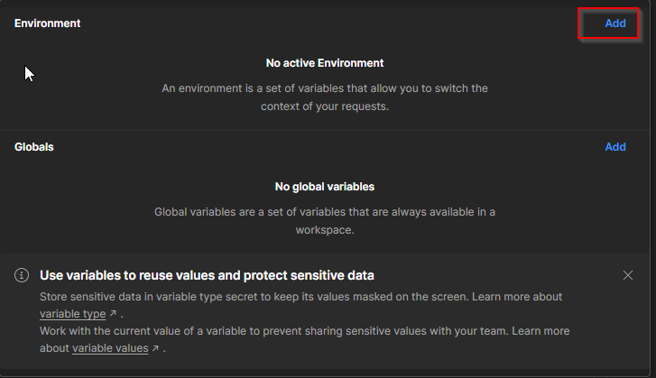

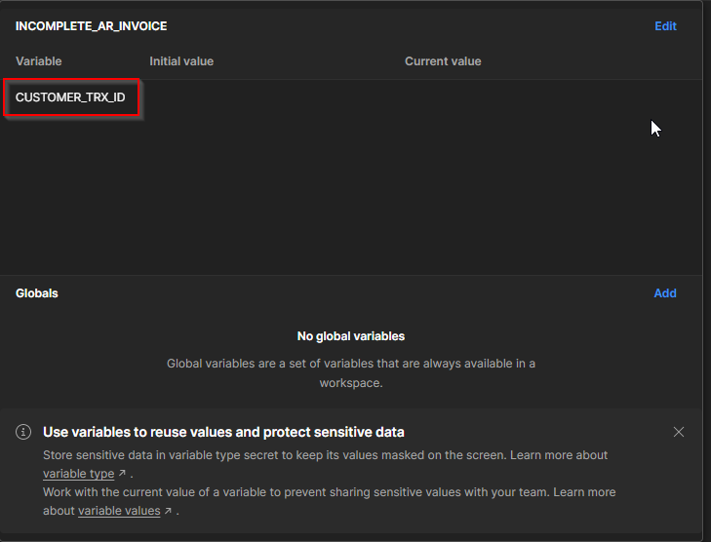

- Create Postman collection and add request under that postman collection.
Go to New-->Collection.
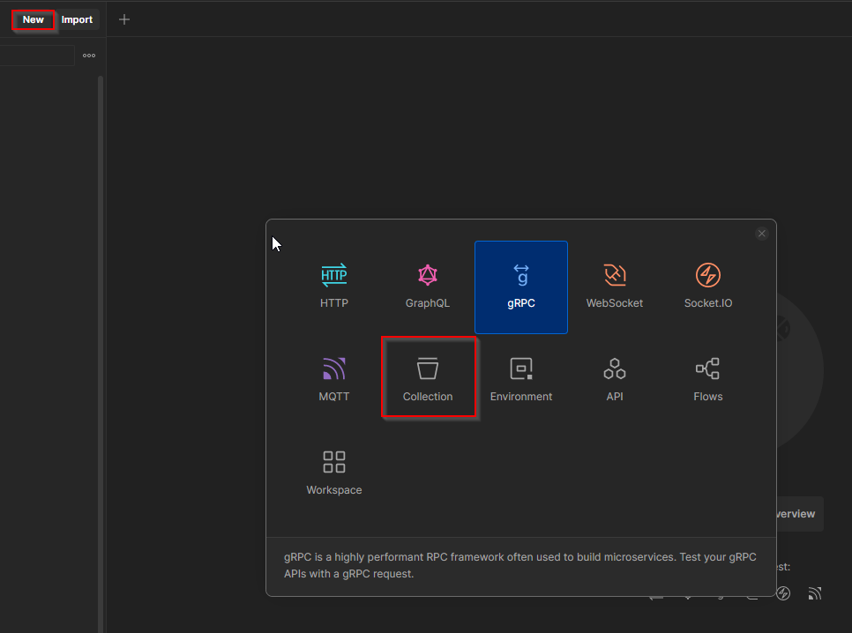

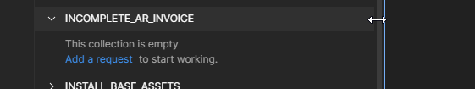
Now add respective REST/SOAP API request under this collection.
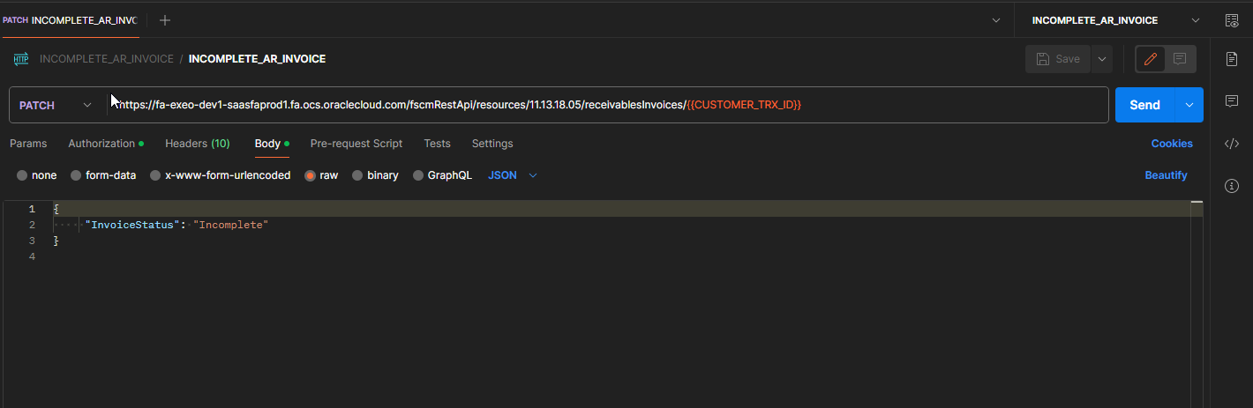
Note: We need to test REST/SOAP API standalone before including in postman collection for sample record.
We can use bind variables in payload also depending on payload which we are using.
Also select the environmental variable which we have created in step1 from list of values.
Save the request and collection.

- Create csv file for bulk record:

We need to create csv file for bulk record with below conditions:
- The header name for column should be same as Environment and bind variables which we are using in collection.
- File should be comma separated.
- File extension should be .csv.

Sample file for AR Invoice Update:
Create BIP report to extract bind variable values from Fusion instance.

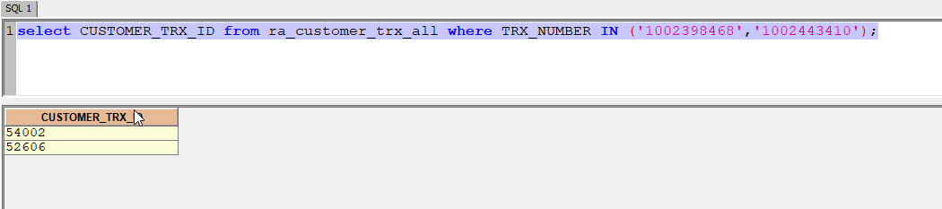

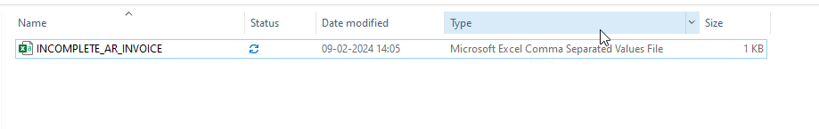

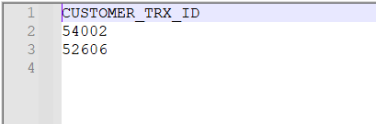

- Run the collection to update data.

Go to collection ----> View More actions.

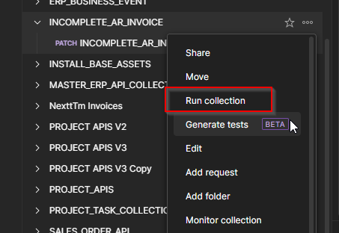

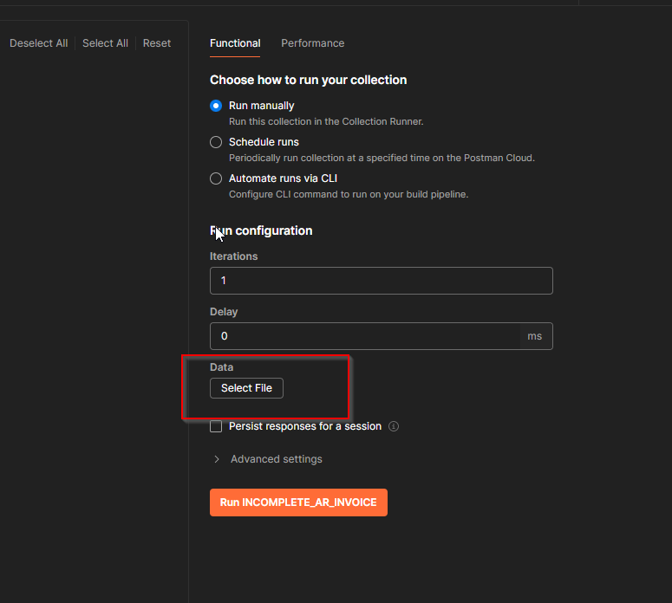
Click on Select file to select csv file.

Click on Run collection.
It will start executing request for each record as per file.

